
Requirements Analysis Document (RAD) for
PSPF Record Tracking System

Public Service Pension Fund

Document Version 1.1

Prepared By:
Neeraj Panwar
Project Lead
Misha Infotech Private Limited
Email ID- neeraj.p@mishainfotech.com www.mishainfotech.com
Tel No: 011-65732683
USA: +1-(917) 503-0924, +1-(917) 688-4201

- Login Screen
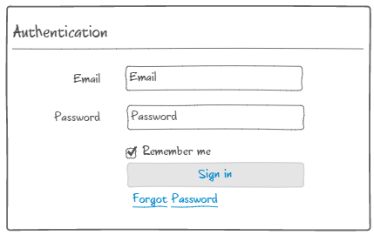
  - Login window
See above.

  - What’s in the login window
- Username
- Password
- Remember me

  - Buttons
- Sign in for users login

  - Link
- Forgot Password to be opened new screen to reset your password.
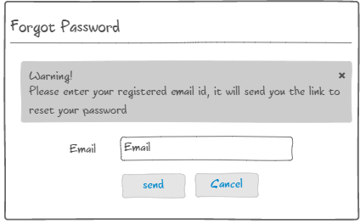
  - Operations
- Open app，input Username, Password。
- Select remember me, Next time login go to logged in user’s dashboard screen。
Click Login if Username correct it will allow using otherwise it will show error message。After successful login the next screen will be user dashboard screen.
- User Dashboard
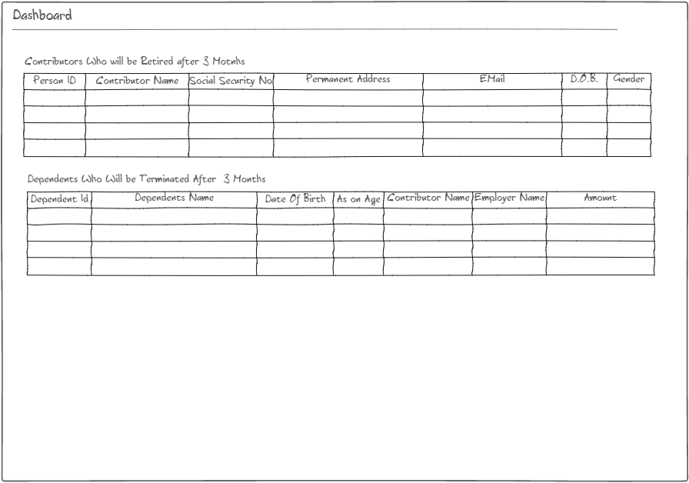
  - Contributors List Who will be retired after 3 months
  - Dependents List Who will be terminated after 3 months

- Employer Details
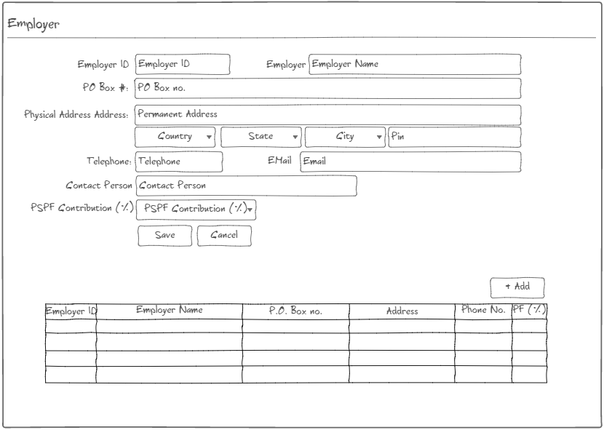
  - Employer Details window
See above.

  - What’s in the Employer Details window
- Employer ID (Auto generated PSPF Unique ID)
- Employer Name
- PO Box #
- Address with Country, State City and Postal Details
- Telephone
- Mail Id
- Contact Person
- PF Contribution (%)

  - Buttons
- Add Add new Company details
- Save for save details
- Cancel Cancel Details

- Contributor Details
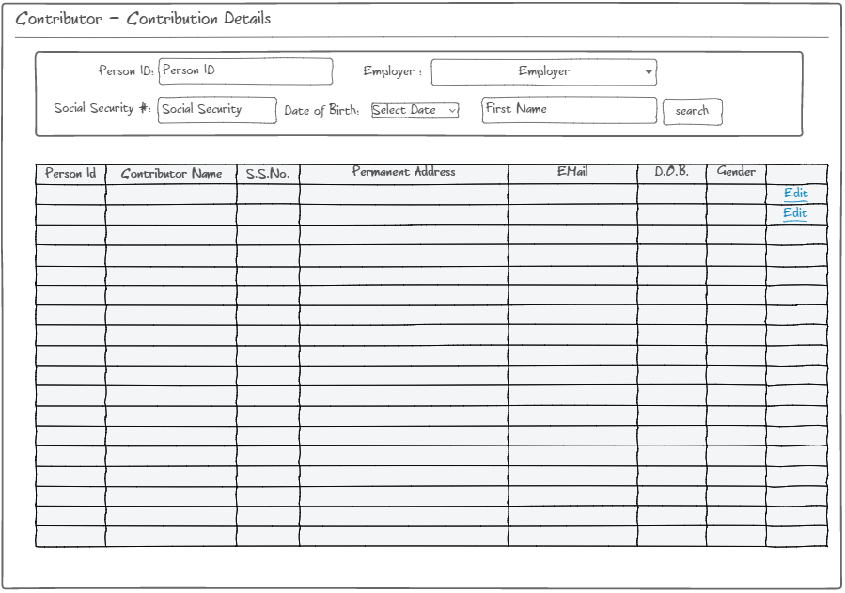
  - Search Criteria Person Id/ Employer / Social Security #/ Data of birth / First Name
  - Contributor List Employer wise contributor list that has these columns:- PSPF unique, Contributor Name (First Name + Mid Name + Last Name), Social Security #, Permanent Address, Email, D.O.B. (date of birth), Gender

  - Operations Edit on a particular row it will open that particular’s contributor detailed screen where you can edit the information.

- Contributor Personal Detail
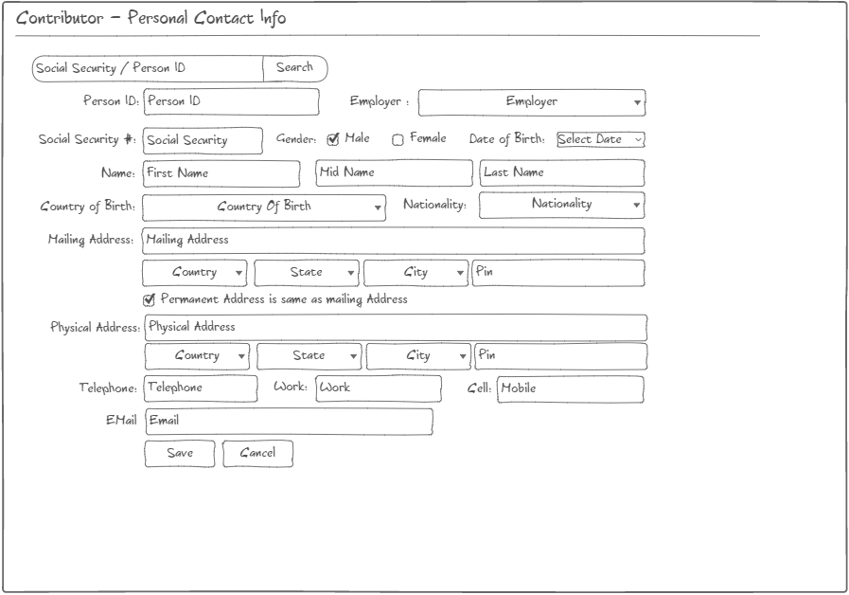
  - Contributor Personal Details window
See above.

  - What’s in the Contributor Personal Details window
- Person ID (PSPF Unique ID)
- Employer
- Social Security #
- Gender (Male / Female)
- Date of Birth
- Name (First, Mid, Last)
- Country of birth
- Nationality
- Mailing address with Country, State City and Postal Details
- Checkbox for Permanent Address is same as mailing address
- Permanent address with Country, State City and Postal Details
- Phone (Telephone, work, cell)
- email
  - Buttons
- Search will search result against social security #
- Save for save details
- Cancel Cancel details

- Marital Status
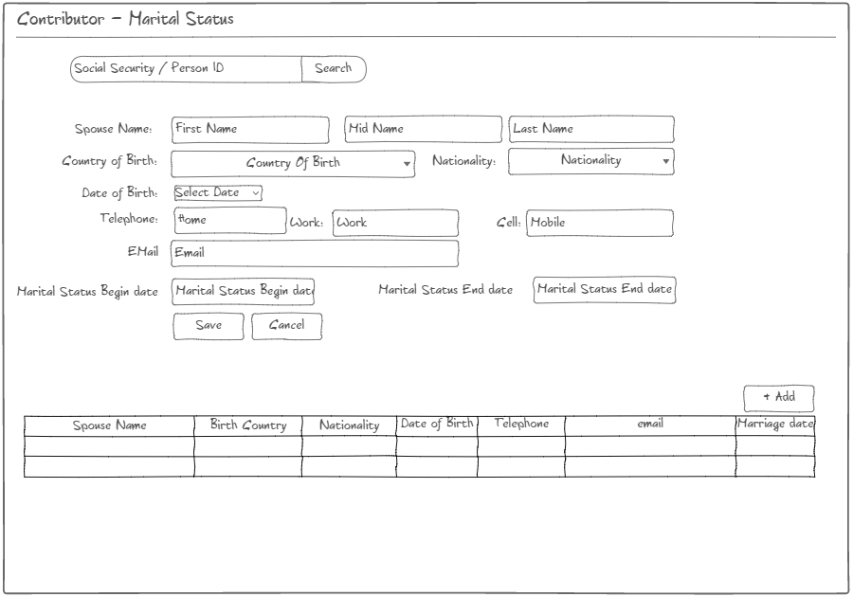
  - Contributor ‘s Marital Details window
See above.

  - What’s in the Contributor ‘s Marital Details window
- Spouse Name (First, Mid, Last)
- Country of birth
- Nationality
- Date of Birth
- Phone (Telephone, work, cell)
- email
- Marital Status Begin Date
- Marital Status End Date

  - Buttons
- Search will search result against social security #
- Save for save details
- Cancel Cancel details
- Add Add multiple entries for the contributor’s marriage

  - Listing
Spouse Name, Birth Country, Nationality, Date of birth, telephone, email, Marriages Date
- Dependents Details
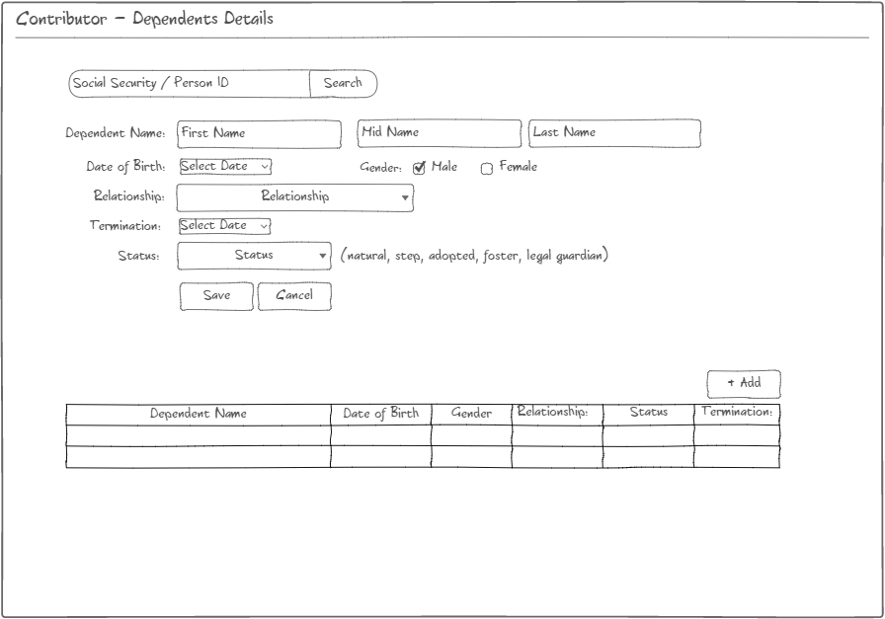
  - Contributor Dependents Details window
See above.

  - What’s in the Contributor Dependents Details window
- Dependents Name (First Name, Mid Name, Lat Name)
- Date of Birth
- Gender Male / Female
- Relationship
- Termination
- Status
  - Buttons
- Save for save details
- Cancel Cancel details
- Add Add multiple entries for the contributor’s Dependents

  - Listing
Dependent Name, Date of birth, Gender, Relationship, status, termination

Business Rule: Allow only those Dependents whose under age are 18 and 19 for dependents of police

- Job Information
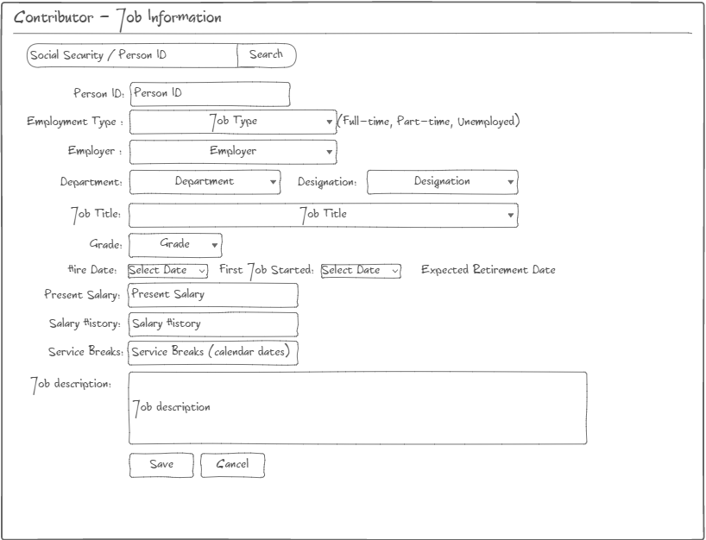

  - Contributor Job Details window
See above.

  - What’s in the Contributor Job Details window
- Person ID (PSPF)
- Employment Type Fill Time, Part Time, Unemployed
- Employer
- Department
- Designation
- Job Title
- Grade
- Hire date
- First Job Started
- Expected Retirement Date:- will automatically calculated from DOB and max retirement years
- Present Salary
- Salary History
- Service Breaks
- Job Description
  - Buttons
- Search will search result against social security #
- Save for save details
- Cancel Cancel details
Question:
- Could it be single entry of a contributor?
- How the Salary History and Service Breaks details maintain?

- Contribution Details
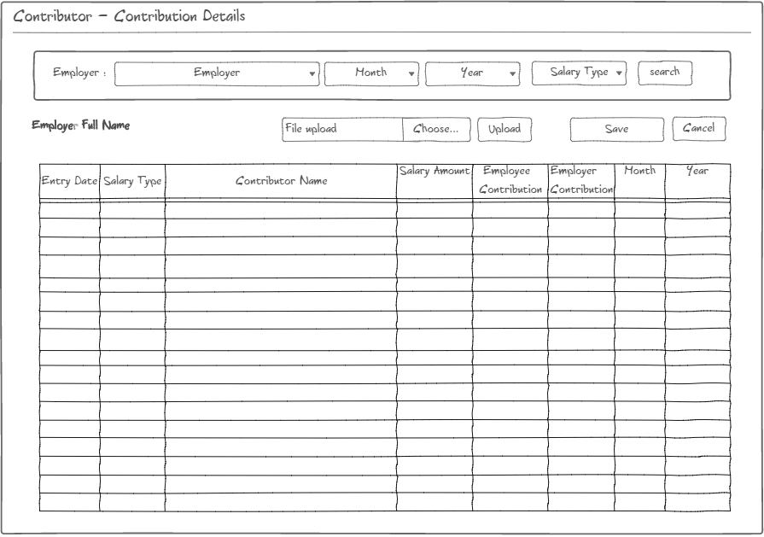
  - Search Criteria Employer / Month / Year / Salary Type
  - Contribution List Entry Date, Salary Type, Salary Amount, Employee Contribution, Month, Year, Employer Contributor, Month & year
  - Buttons
- Search for search details based on above selected criteria
- Choose Allow user to choose predefined file format sent by employer to PSPF
- Save for upload and save details
- Cancel Cancel details

  - Operations Allow user to choose predefined file format sent by employer to PSPF

- Contributor’s Refund Amount Details
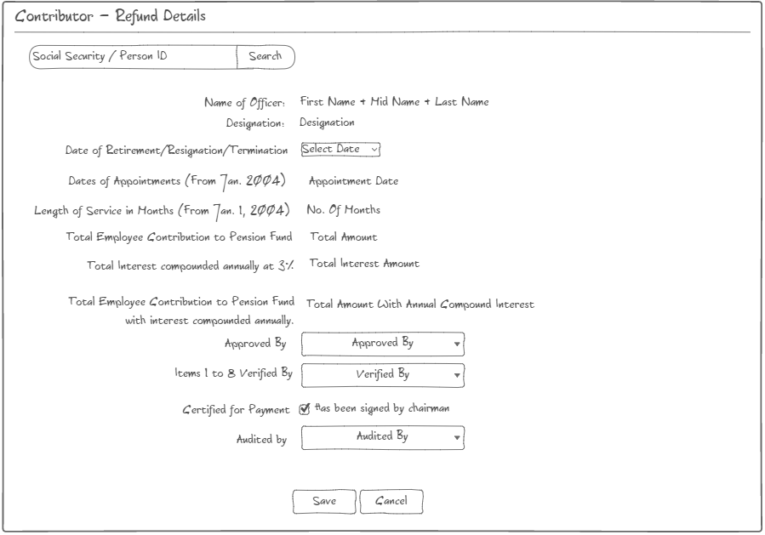
  - Contributor’s Refund Details window
See above.

  - What’s in the Contributor Refund Details window
- Name of Officer (First Name, Mid Name, Lat Name)
- Designation
- Retirement / Resignation / Termination Date
- Appointment date (from January of current year)
- Length of service (from January of current year)
- Total interest compound annually at 3%
- Total Employee contribution to pension fund with annual compound interest amount
- Approved by
- Point 1-8 verified by
- Certified for payment has been signed and approved by chairmen
- Audited by
  - Buttons
- Save for save details
- Cancel Cancel details
- Search Get details based on social Security #/ PSPF ID

  - Operations Once contributor / officer will be complete the PSPF application form and submitted to PSPF department, then PSPF person will check contributor’s details based on social Security #/ PSPF ID

- Pensioner Details
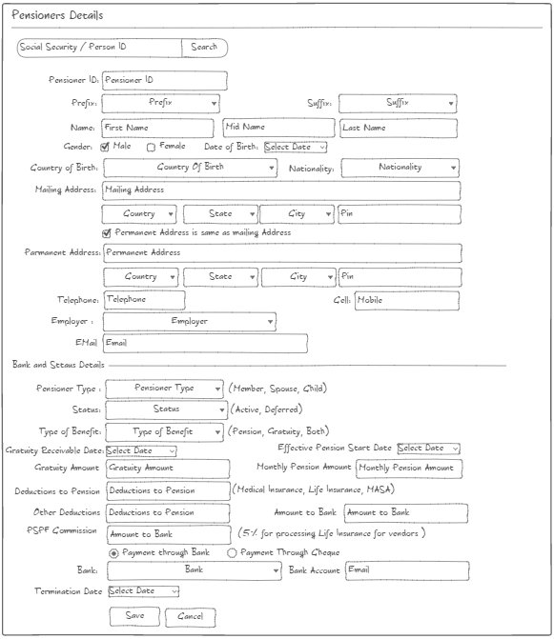
There are 35 active pensioner whose pension are generated by PSPF department in every month, the pensioner collect their pension either from PSPF department or collect from bank So the PSPF department deposited such pensioners pension to the bank.

- Pensioner’s Payroll Generation
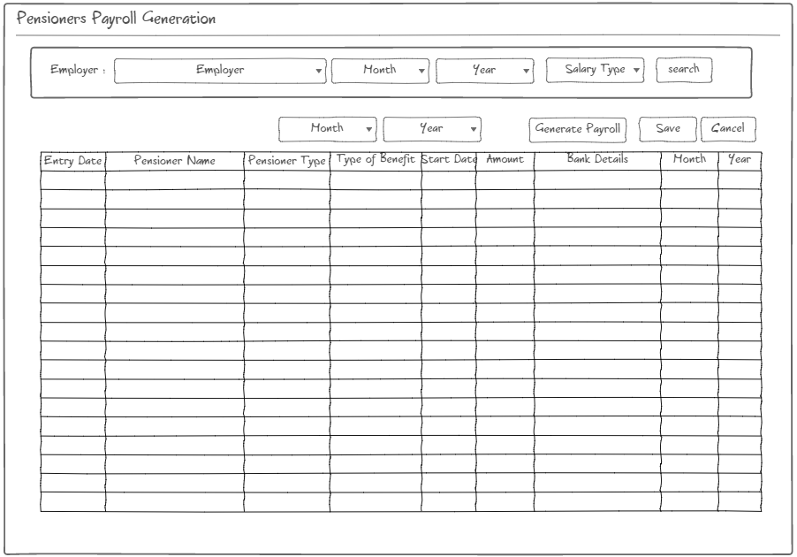
Once payroll has generated successfully then user can recheck and finalize the payroll. Once payroll has finalized then user can’t update anything in that payroll.

- Pensioner’s Payroll Rechecking & Finalize
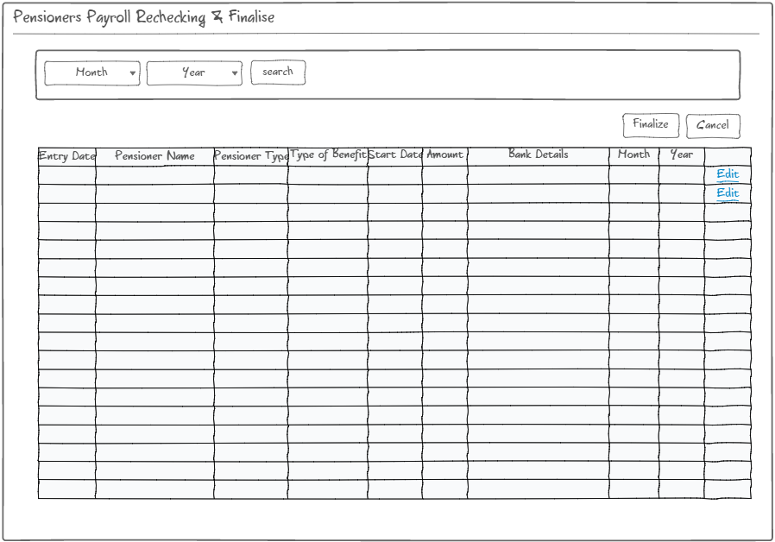

- Pensioner’s Payment through cheque
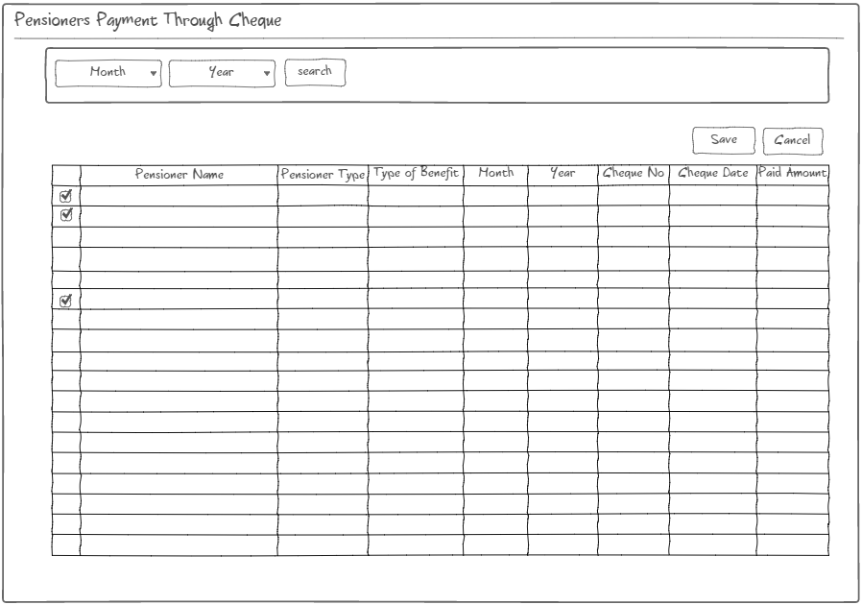
- Pensioner’s Pension Transfer in Bank
Need to discuss with client.

- Role Master
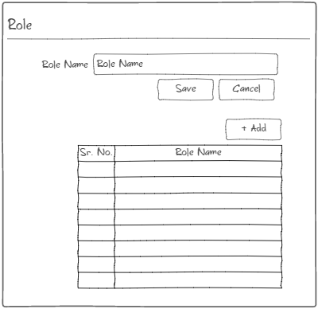
- User Management
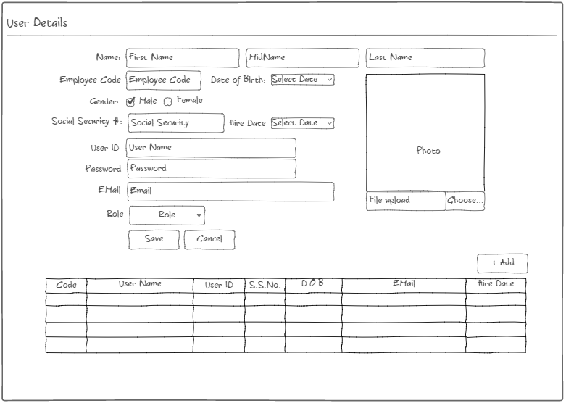

- Role Module
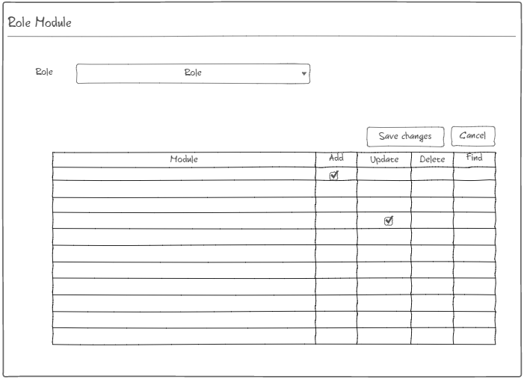

- Masters
Here are following master’s lists that will be used in the PSPF application
Prefix, Suffix, Bank, Employer, Country, State, City, PFPercentage, Department, Designation, Grade, Month, Nationality, PansionType, Relationship, Status
  - Prefix
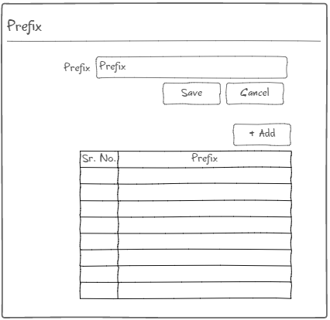

  - Suffix
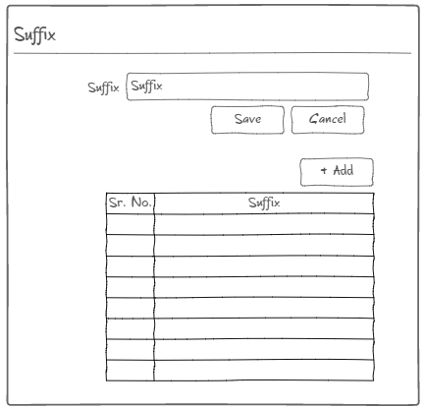

  - Bank
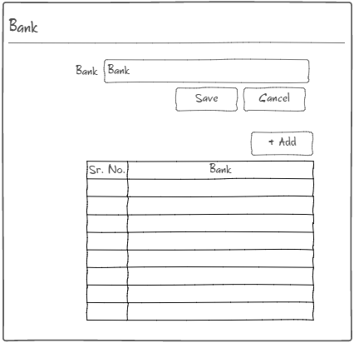

  - Country
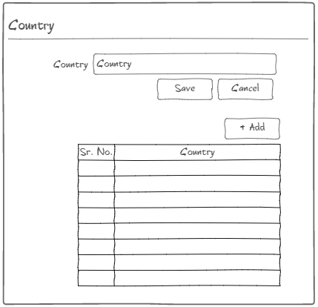

  - State
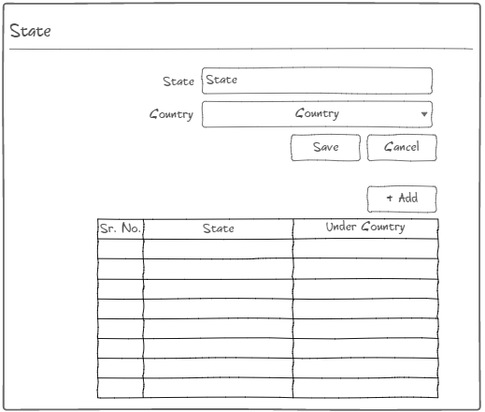

  - City
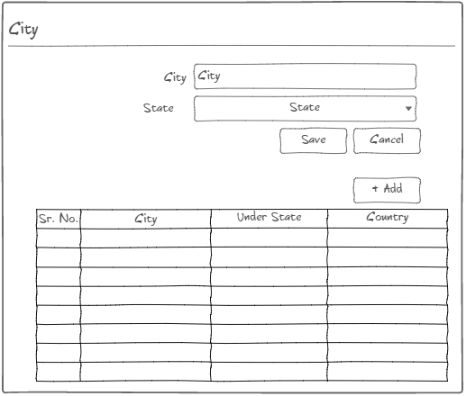

  - PFPercentage
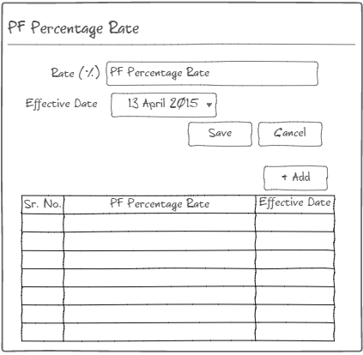

  - Department
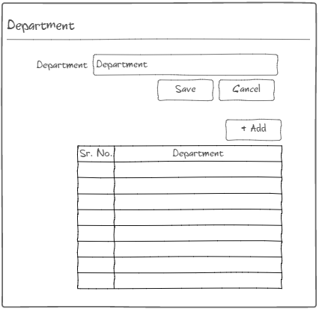

  - Designation
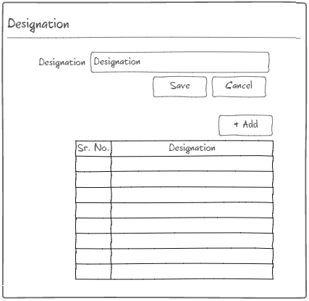

  - Grade
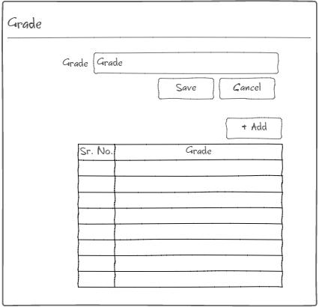

  - Month
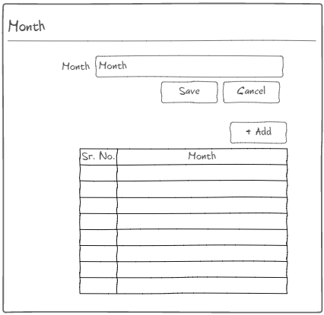

  - Nationality
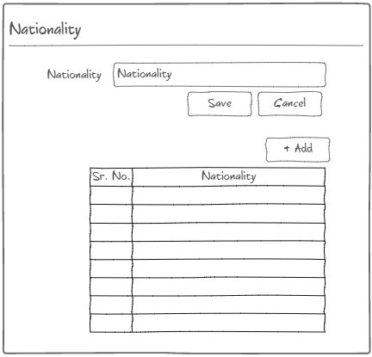

  - Pension Type
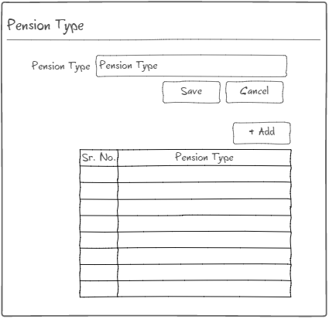

  - Relationship Type
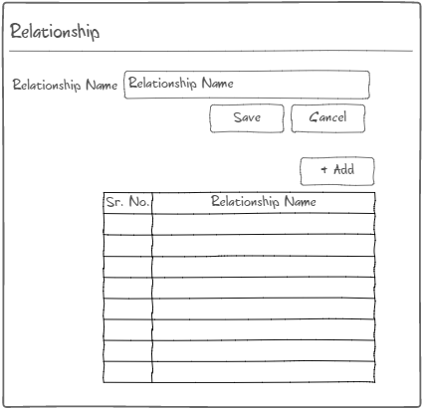

  - Status
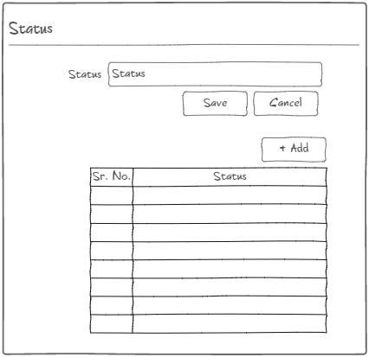

- REPORTS
Examples of reports to be generated
- Monthly contributions by employer
- Monthly contributions by employee
- Total pension contributions by month
- Total pension contributions by year
- Pension Contributions by bank
- Monthly payments to Insurance Companies, MASA etc.
- Total pension benefits by month
- Total pension benefits by year
- Retirement by year

